**SIDCmd** [**User Guide**](javascript:;)

What should be provided to the user?

1. SID_Project folder, containing SID’s dll and exe
2. acis folder, containing acis’dll
3. iop folder, containing iop’dll
4. hoops folder, containing hoops’dll
5. v8 folder, containing v8 engine’s dll
6. SID_MiSUMi.zip, containing the demo codes.

What environment variables the user should add?

1. Add two new system variables:

V8_HOME and the value is v8 folder;

SID_Project and the value is SID_Project folder;

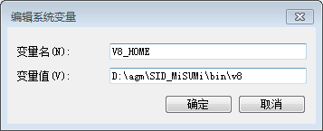

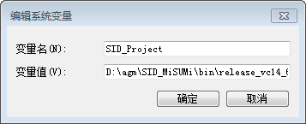

1. Add %acis%\NT_VC14_64_DLL\code\bin;%iop%\NT_VC14_64_DLL\code\bin;%hoops%\bin\nt_x64_vc14;%v8%\bin\x64 to the “Path” variable.

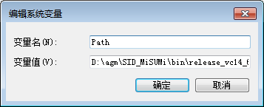

Do NOT delete the existing value in “Path”!

You can add the above paths before the existing value of “Path”.

%acis%, %iop%, %hoops%, %v8% is the folder of acis, iop, hoops and v8 in your laptop.

How to use the C# demo codes?

1. SIDCmd.zip is the demo code and unzip it first
2. Start SIDCmd\SIDCmd.sln and you can see the demo project – SIDCmd

I am using VS2015 to develop the SID Project and this demo, so you should better to use VS2015

1. The structure of SID Project can be simply described as following:

Demo codes for you

SIDModelingDll.dll

C++ dll

call

call

SIDCmd.exe

C# exe

SIDCmdDll.dll

C# dll

call

Low level C++ dll

Modeling dll, Javascript dll, Sketcher dll…

acis dll, hoops dll, interop dll, v8 dll…

call

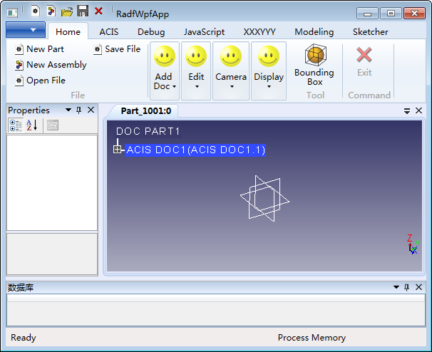

C++\CLI wrapper layer

C#\WPF UI

The projects which is visible to you is SIDCmd.

~~SIDCmdDll contains the codes how to parse the command-line arguments input to SIDCmd and call modeling api in SIDModelingDll.dll. You do NOT need to change the codes in this dll.~~

~~SIDCmdDll里面包含了如何解析命令行参数，如何处理csv表格，如何调用SIDModelingDll.dll里面的建模命令的代码，我也可以把这个工程里面的代码都封装起来，只留个接口给日本调用；但是我觉得没必要封装，底层的c++建模命令我已经封装了，这部分代码开放给他们看也无所谓。你们可以跟日本那边强调不需要看这部分代码，这部分代码是我这边维护的。这部分代码开放给他们的目的是让他们可以在自己的程序（类似SIDCmd）里面引用这个工程。~~

SIDCmd is showing you how to use SIDCmdDll in your application:

1. reference SIDCmdDll into your project;
2. using SIDCmdDll;
3. input parameters;
4. call ModelingCmd.CreateModel;
5. Build the solution; you can get SIDCmd.exe in SID_Project folder.

What is the meaning of the input parameters and return value of ModelingCmd::CreateModel?

1. The input parameters:

-file : the input csv file path

-r : the row number of the csv file

-format : the output file formats, separated by "|"; now support iges, sat and step. For example you can use “sat” to output only sat file and “sat|iges|step” to output files of three formats.

You can use cmd to start SIDCmd.exe: SIDCmd.exe -file "D:\SINUS-3D\StagingEnvironment\JS-data\AJX051950P2.csv" -r -format "step|sat|iges"

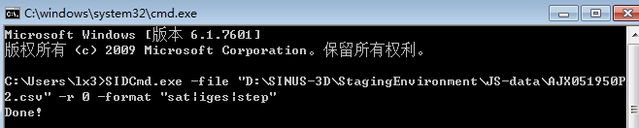

1. The return value:

int : 0 means succeed; other value means error.